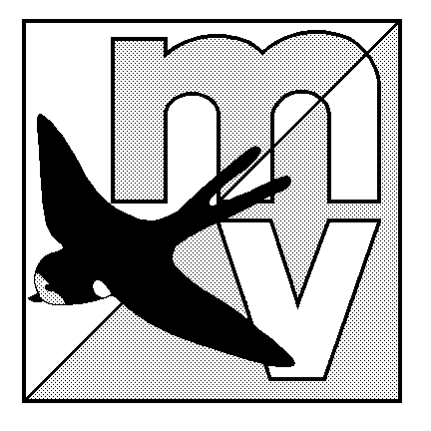 MOLE VALLEY ORIENTEERING CLUB
(Affiliated to the British Orienteering Federation)

LIMITED DISTRICT EVENT
The Nower, Dorking
Sunday 6th June 2004
(In conjunction with The 27th Surrey Hill Races)

Venue Small but interesting area of mostly runnable woodland, with many paths. All facilities are close together, there is an ideal grassy area to have a picnic on after your run!

Car Park The Priory School, Dorking, Surrey. OS Map 187, at GR 158488.
Follow ‘Hill Race’ sign from South end of Dorking one-way system.

Map 1:5000 updated for winter 2002.
Registration 10.00 - 12.00 Entry on the day only.

Starts 10.30 - 12.30 Courses close 14:30

Courses & Yellow, Orange and Green only. The event will be using SportIdent electronic
Punching punching (hire charge £1).

Fees Seniors £4.00. Juniors £1.50.

Facilities Squash, toilets at the school, dogs welcome.

Officials Organiser: Mark Rowe 020 8844 1370 mark.rowe@fsmail.net
Planner: Bill Alexander Controller: Simon Ling

MV Web Site http://www.mvoc.org/

Safety Whistles recommended.

Competitors participate at this event at their own risk

MOLE VALLEY ORIENTEERING CLUB
(Affiliated to the British Orienteering Federation)

LIMITED DISTRICT EVENT
The Nower, Dorking
Sunday 6th June 2004
(In conjunction with The 27th Surrey Hill Races)

Venue Small but interesting area of mostly runnable woodland, with many paths. All facilities are close together, there is an ideal grassy area to have a picnic on after your run!

Car Park The Priory School, Dorking, Surrey. OS Map 187, at GR 158488. Parking at School.
Follow ‘Hill Race’ sign from south end of Dorking one-way system.

Map 1:5000 updated for winter 2002.
Registration 10.00 - 12.00 Entry on the day only.

Starts 10.30 - 12.30 Courses close 14:30

Courses & Yellow, Orange and Green. The event will be using SportIdent electronic
Punching punching (hire charge £1).

Fees Seniors £4.00. Juniors £1.50.

Facilities Squash, toilets at the school, dogs welcome.

Officials Organiser: Mark Rowe 020 8844 1370 mark.rowe@fsmail.net
Planner: Bill Alexander Controller: Simon Ling

MV Web Site http://www.mvoc.org/

Safety Whistles recommended.

Competitors participate at this event at their own risk

